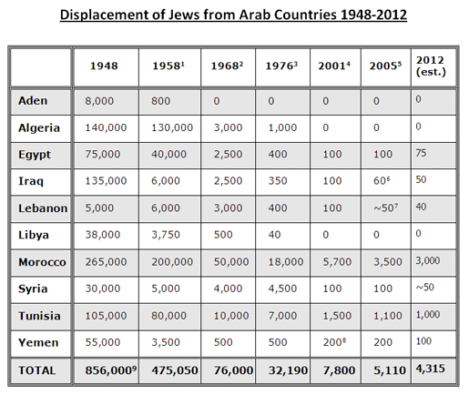

Source: Justice for Jews from Arab Countries (JJAC) - infor@justiceforjews.com 10/13/14.
JJAC uses the figure of 850,000 Jews displaced between 1948 and the early 1970's.

*Aden became part of Yemen in 1948.

